|  |  |
| --- | --- |
|  | PLTW_M_L_4CP |

|  |
| --- |
| **Activity 6.1.5 DC Motor Construction** |

Introduction

|  |  |
| --- | --- |
| Nanotechnologists are working hard to create smaller and smaller motors. Some motors are already 300 times smaller than the diameter of a human hair. Many developers today believe that someday nanomotors will power small nanomachines that will roam through the bloodstream fighting and curing disease. |  |

Equipment

* AA battery
* AA battery holder
* ¾ x 1 ½ x 2 ¼ in. pine board
* 2 - 2 ¼ in. 12 gauge copper wires (common household)
* 2 ft – 22 gauge magnet wire
* 1 in. x ¾ in. x 3/16 in. magnet
* Needle nose pliers
* Wire stripping pliers
* 1/16 in. drill bit
* 1 in. diameter dowel rod (approximately 4 in. length)
* Hot glue gun with glue

Procedure

You will create a simple DC motor to demonstrate how a magnetic field and electric current can create rotary motion.

1. Begin with a ¾ x 1 ½ x 2 ¼ in. base and mark the following center points as dimensioned below.

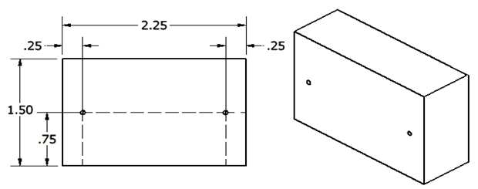

1. Drill 1/16 in. holes through the block at the marked center points.
2. Use needle nose pliers to create a small loop in each 2 ¼ in. copper wire.

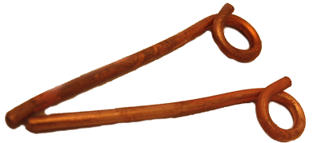

1. Gently push the copper wires into the holes that were drilled.
2. Hot glue the battery case to the front of the base.

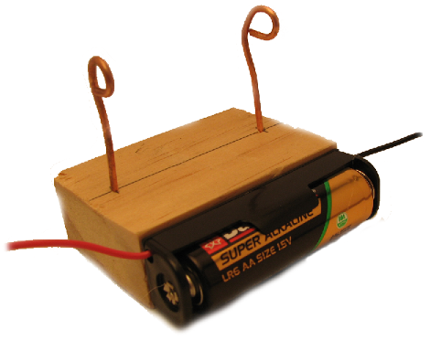

1. Place the magnet on the center of the top of the base.
2. Wrap one wire from the battery case around one of the copper wires. Create a hook shape with the other wire. You may need to strip more insulation from the battery case wires to obtain a good connection.

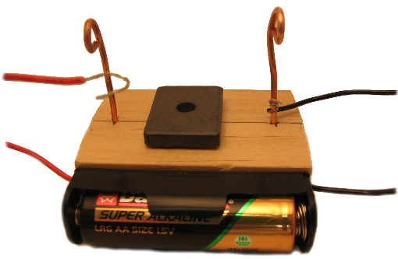

1. Starting about 1 ½ in. from the end of the magnet wire, begin wrapping the magnet wire around the 1 in. dowel rod several times. Leave about 1 ½ in. on the other end.
2. Wrap each end of the wire as seen below two or three times around the coil so that each support has about 1 in. of wire on each end. The supports should be directly across from each other.

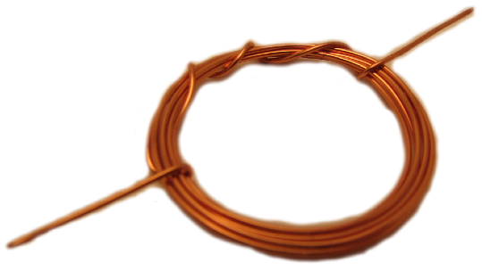

1. Using sandpaper, lightly sand one end of the wire completely around to remove all insulation (varnish).
2. To make the commutator, carefully sand the top surface only on the other straight end.
3. Place the coil into the copper supports. Push the copper supports into the wood until they are level and the coil is just above the magnet.
4. Touch the unattached wire from the battery case the copper support that is not connected to the other wire.
5. Try spinning the coil in both directions to see if it will continue to spin.

Improve Your Motor

Your motor may not immediately spin. It also may be possible to make the motor spin faster. The process of modifying your design for improvements is often referred to as tweaking. Engineers do a lot of tweaking, but not generally without a plan.

In your engineering notebook, list three or more details that you could try to improve about the performance of your motor. Describe why each modification might make a difference in your motor’s performance. Make your tweaks one at a time and record the results of each as you improve your motor design.

Conclusion

1. Which part of this motor represents the armature?

The coiled magnetic wire.

1. What is the relationship between slip rings and how you sanded the ends of the looped magnet wire?

The half of the mganetic wire that wasn’t sanded would break the circuit every time it spun on the copper rings, which also stopped the magnetic field so the armature could continue spinning.

1. Why does the coil need a little shove to get started?

The coil needs a shove because it can’t start spinning, which completes the circuit and turns on the magnetic field, by itself.

1. Why is there only one permanent magnet in the motor design?

There is only one permanent magnet in the design because only one magnet is required. More could make the armature spin faster.

1. How could you get the motor to spin in the opposite direction?

Change the direction of the flow of electrons, switch positive and negative or flip the magnet.

1. What happens if you add more magnets?

If you added more magnets, they could either make it spin faster, or stop it depending on where you placed it.

1. What happens if you flip the magnets?

The magnets would do the opposite of what they were previously doing, push or pull, and make the armature spin the other way.

1. What happens if you alter the voltage?

The armature spins faster if you increase the voltage and slower if you decrease the voltage.